**FACTORS AFFECTING THE PERFORMANCE OF IPO**

**______________________________________________________________________________________**

**M.Sc. Statistics and Data Science 2021-2023**

**__________________________________________________________________________**

**Group no:**8

**Group members**

Athul Nair 75322100001

Raghav Swaroop Varma 75322100006

Lizel Rodrigues 75322100009

Kaivalya Modak 75322100019

Rhythm Rastogi 75322100025

Dhruv Kumar Dhandhukiya 75322100047

**Mentors**

Dr. K.S. Madhava Rao- Professor (Statistics)

Dr. Pradnya Khandeparkar- Associate Professor (Statistics)

___________________________________________________________________________________________________

**Table Of Contents**

**Glossary** 3

**Introduction** 6

**Purpose of the study** 7

**Objective** 7

**Literature Review** 7

**Data Collection** 8

**Data Cleaning Methodology** 9

**Exploratory Data Analysis** 9

**Statistical Methodology** 11

➢ Principal Component Analysis (PCA) 11

➢ Multiple Linear Regression (MLR) 12

**Statistical Analysis** 13

**Conclusion** 18

**Limitations** 18

**Future Scope** 18

**References** 19

**Appendix** 19

# Glossary

* **BSE (Bombay Stock Exchange)**

The Bombay Stock Exchange is the first and largest securities market in India and was established in 1875 as the Native Share and Stock Brokers' Association. Based in Mumbai, India, the BSE lists close to 6,000 companies and is one of the largest exchanges in the world, along with the New York Stock Exchange (NYSE), Nasdaq, London Stock Exchange Group, Japan Exchange Group, and Shanghai Stock Exchange.

* **CFOA (Cash from Operating Activity)**  Cash flow from operating activities is a part of a company's cash flow statement that provides information about the total income generated by a company from ongoing business activities, its sources, and its uses.
* **CMIE (Centre for Monitoring Indian Economy)**

Centre for Monitoring Indian Economy is an independent non-government entity that serves both as an economic think-tank and a business information company. CMIE research group has built databases on the Indian economy and private companies. CMIE provides this information in the form of databases and research reports via a subscription-based business model.

* **CPI (Consumer Price Index)**

The consumer price index (CPI) measures changes over time in the general level of prices of goods and services that a reference population acquires, uses or pays for consumption. User fees (such as water and sewer service) and sales and excise taxes paid by the consumer are included in CPI.

* **CRR (Cash Reserve Rate)** The percentage of cash required to be kept in reserves as against the bank's total deposits, is called the Cash Reserve Ratio. Under cash reserve ratio (CRR), commercial banks must hold a certain minimum amount of deposit as reserves with the central bank. In technical terms, CRR is calculated as a percentage of net demand and time liabilities (NDTL).
* **ER (Exchange Rate (Rupees to US Dollar))**

An exchange rate is the rate at which one currency will be exchanged for another currency. So, in this study, the exchange rate of Indian Rupees to US Dollar is considered.

* **HNI (High Net-worth Individual)**

A high Net-worth Individual (HNI) is a retail investor who bids for more than Rs 200,000 equity shares in an IPO. It is an investor category defined in IPOs in India. They need not to register with SEBI like RIIs. Generally, high net-worth Individuals have an allocation of 15% of shares of the total issue size in Book Build IPO's.

* **IS (Issue Size)**

Issue Size means the total number of shares issued or proposed to be issued by a company.

* **IPO (Initial public offering)**

Initial public offering or stock market launch is a type of public offering in which shares of a company are usually sold to institutional investors that in turn, sell to the general public, on a securities exchange, for the first time. Through this process, a privately held company transforms into a public company. Initial public offerings are mostly used by companies to raise the expansion of capital, possibly to monetize the investments of early private investors, and to become publicly traded enterprises.

* **IP (Issue Price)**  The price at which a new security will be distributed to the public prior to the new issue trading on the secondary market. Also commonly referred to as offering price. It is the price at which they are offered for sale when they first become available to the public.
* **LP (Listing Price)** Listing price refers to the opening price of the share when it first makes a debut on the stock exchange. The listing takes place after the three-day IPO when investors subscribe for the shares. The allocation of shares takes place after the IPO.
* **NP (Net Profit)** A company's net profit is also known as its net income, net earnings or bottom line. It represents the financial standing of a company after all its expenses have been paid off from its total revenue.
* **NSE (National Stock Exchange)**

National Stock exchange also known as National Stock Exchange of India Limited is the leading stock exchange of India, located in the city of Mumbai, Maharashtra. It is under the ownership of some leading financial institutions, banks, and insurance companies. NSE was established in 1992 as the first dematerialized electronic exchange in the country. NSE was the first exchange in the country to provide a modern, fully automated screen-based electronic trading system that offered easy trading facilities to investors spread across the length and breadth of the country.

* **QIB (Qualified Institutional Buyers)**

Qualified Institutional Buyers are those institutional investors who are generally perceived to possess expertise and the financial muscle to evaluate and invest in the capital markets. Qualified Institutional Buyer includes public financial institutions, commercial banks, mutual funds, and Foreign Portfolio Investors etc. QIBs are mostly representatives of small investors who invest through mutual funds, ULIP schemes of insurance companies and pension schemes.

* **RR (Repo rate)** Repo rate refers to the rate at which commercial banks borrow money by selling their securities to the Central bank of our country i.e., Reserve Bank of India (RBI) to maintain liquidity, in case of shortage of funds or due to some statutory measures.
* **RRR (Reverse repo rate)**  Reverse repo rate is the rate at which the central bank of a country (Reserve Bank of India in case of India) borrows money from commercial banks within the country. An increase in the reverse repo rate will decrease the money supply and vice-versa, other things remaining constant.
* **ROCE (Return on capital employed)** Return on capital employed (ROCE) is a financial ratio that measures a company's profitability in terms of all of its capital. Return on capital employed is similar to return on invested capital (ROIC). A higher ROCE shows a higher percentage of the company's value can ultimately be returned as profit to stockholders. As a general rule, to indicate a company makes reasonably efficient use of capital, the ROCE should be equal to at least twice current interest rates.
* **RII (Retail Individual Investor)**

Retail Individual Investors are resident Indian Individuals, NRIs (Non-resident Indians) and HUFs (Hindu Undivided Families) who applies for less than Rs 2 lakhs in an IPO. Retail Individual Investors have an allocation of not less than 35% of shares of the total issue size in book build IPO’s.

* **SLR (Statutory Liquidity Ratio)** Statutory Liquidity Ratio is a minimum percentage of deposits that a commercial bank must maintain in the form of liquid cash, gold or other securities. It is the reserve requirement that banks are expected to keep before offering credit to customers. These are not reserved with the Reserve Bank of India (RBI), but with banks themselves. The SLR is fixed by the RBI.
* **TLA (Total Liabilities)**  Total liabilities are the combined debts and obligations that an individual or company owes to outside parties. Everything the company owns is classified as an asset and all amounts the company owes for future obligations are recorded as liabilities.
* **Underpricing**

Underpricing is the practice of listing an initial public offering (IPO) at a price below its real value in the stock market. When a new stock closes its first day of trading above the set IPO price, the stock is considered to have been underpriced. IPO underpricing is the increase in stock value from the initial offering price to the first-day closing price.

# Introduction

An Initial Public Offering (IPO) refers to the process of issuing shares of a private firm to the public in a fresh stock issue. An IPO allows a company to raise capital from public investors. The transition from a private to a public company can be a crucial opportunity for private investors to fully realise gains from their investment, as it typically includes a share premium for current private investors. Meanwhile, public investors are allowed to participate in the offering.

Several companies, ranging from tech start-ups to chemical manufacturing firms and restaurant chains, have gone public in 2020-21. More firms are expected to take the initial public offering (IPO) route to get listed on domestic stock markets later this year. Investment bankers tracking IPOs suggest that it will be a record year for fundraising. Thirty companies have already filed IPO papers to raise Rs 55,000 crore and at least 10-15 more are lined up to initiate the process of going public and raise another Rs 25,000 crore. So far this year, companies have already raised the highest amount through the IPO route in over a decade. Despite the impact of the Covid-19 pandemic, it seems the country will witness a record number of IPOs this year. Similar trends have been seen during previous bull markets.

A bull market is an extended period when prices are rising in a sustained manner, especially when large numbers of investors are buying and holding stocks. Bull markets are often characterised by high investor confidence and rising asset prices. The market is filled with enthusiasm and intrigue. It is also accompanied by sustained economic development, having good volumes of liquidity in the market. This flow of money to investors enables investors to invest more in the stock market.

IPOs are launched in a bullish market to ensure that the company's stock is oversubscribed. This is because during a bull market there is a good amount of cash flow and enthusiasm in the market. If the stock is oversubscribed, it means that the stock is extremely popular and investors have an interest in holding it apart from strong listing gains. This makes it highly likely that the stock price will skyrocket in the future. Thus, the new shares will be worth a lot more in the future.

There is no doubt that the demand for new shares is important for investors. However, it is equally important for the company because it ensures that the company has a robust demand for its stock. Thus, the company needs to ensure that there are a lot of people who hold its stock. If the stock is not oversubscribed, it means that there is not much enthusiasm for it. This makes it extremely unlikely that the stock price will go up in the future. In such a scenario, the company will have to struggle to get investors interested in the stock. This makes it very unlikely that the company will be able to raise enough money to sustain itself in the future. But often investing in IPOs during bull runs may be risky. This is because most IPOs do not perform well in the long run. During bear markets, when shares of fundamentally weak companies crash, and it is the investors who bear the loss. Therefore, it is always advised to check the fundamentals and balance sheets of a company before applying for the company’s IPO.

Given these circumstances, we wish to analyse the factors affecting the listing price of such Initial Public Offerings (IPOs).

# Purpose of the study

The goal of this quantitative study is to gain a better understanding of the primary factors that can influence the performance of the listing price of the IPOs, thereby expanding our knowledge and having better opportunities for future investment.

# Objective

* The main objective of this research paper is to find out which factors significantly affect the listing price of an IPO. The factors being considered here are variables such as macroeconomic factors, listing and subscription related factors and company financials.
* To provide a linear equation for future prediction of listing price on the basis of independent variables.

# Literature Review

**Kedar M Phadke** and **Dr. Manoj S Kamat (2018)** in their research study observed the performance of 239 IPOs introduced during 2000-2014 on NSE. They applied the Principal Component Analysis (PCA) technique on different macroeconomic variables to determine factors to be considered for performing the multiple regression analysis. In the analysis, all the independent variables (macroeconomic variables) except the exchange rate were regressed against the level of under-pricing. The analysis indicated that there was a negative relationship observed between the mid-cap and the large cap stocks with a marginally adjusted return on opening. The research study also revealed that the large issue size leads to an increase in the supply of shares in an issue and hence reduced under-pricing.

**Savya D.S (2020-21)** analysed the listing day performance of IPO in the market and also checked for correlation between issue price and short-term return, issue size and short-term return. In this research paper, the sector wise division of IPOs during the sample period was also found. It has been observed that the overall primary issue market has faced downward sloping growth in terms of the number of IPOs due to global economic downturn due to pandemic. Also, the correlation results revealed that the independent variables like Issue price and Issue size have weak significant relation with initial day returns of IPO and independent variable.

**Seshadev Sahoo** and **Prabina Rajib** (2010) This paper is motivated by the apparent belief that IPOs are under-priced on the initial listing day and thereafter underperform compared to the market benchmark. It is reported that on an average the Indian IPOs are under-priced to the tune of 46.55 per cent on the listing day (listing day return vis-à-vis issue price).

**Vijaya B. Marisetty** and **Marti G. Subrahmanyam** (2010) This paper documents the initial performance of 2,713 initial public offerings (IPOs) in India during the period 1990-2004. They find that Indian investors over-react to IPOs and their over-reaction (proxied by the oversubscription rate) explains the extent of under-pricing.

# Data Collection

A sample of IPOs of the firms listed from April 2009 (budget year 2009-10) to March 2020 (budget year 2019-20) on the National Stock Exchange (NSE) and Bombay Stock Exchange (BSE) was selected for the analysis. All SME IPOs as well as any Follow-On public offerings also referred to as Secondary Equity Offerings (SEO) have been excluded from this study.

In our study, we have considered three types of variables-macroeconomic variables, subscription related variables and the company financials.

Macroeconomics data was obtained from the portal of CMIE-Centre for Monitoring Indian Economy ([www.cmie.com](http://www.cmie.com) ). The data points obtained from this portal are the money supply (M1, M3), Cash reserve rate (CRR), Statutory liquidity ratio (SLR), bank rate, Exchange rate- Rupees per US Dollar (ER), CPI: Base year 2012, Yield in secondary market (AAA and AA rated corporate bonds), repo rate and reverse repo rate. The data provided on the CMIE website was obtained from the official sources.

The subscription related variables and the listing data variables were obtained from the websites of money control and NSE India. The subscription variables included QIB, HNI, RII and Total subscription. The other variables were issue size (in crores), issue price, listing open and post listing price.

For the macroeconomic variables and the other subscription related variables, secondary data has been considered. But for the company financials, no data was available so it has been primarily collected from sites like [www.screener.in](http://www.screener.in) , [www.chittorgarh.com](http://www.chittorgarh.com), [www.nseindia.com](http://www.nseindia.com) and then compiled with the other variables. The variables obtained were net profit, total liabilities, cash flow from operating activity and Return on capital employed (ROCE.)

# Data Cleaning Methodology

The data set collected for each IPO consisted of variables at the time of listing, macroeconomic factors, and company financials. The sample selection was purely guided by availability of data and has companies for post mandatory requirement. The final sample fulfills the following criteria:

1. IPO must be listed with either NSE or BSE.

2. Only those IPOs on which all the information is available are considered.

3. Company financial statements and notes should be available during the study period.

So, from the total of 232 public offers, 11 IPOs were found to have missing data and so those were filtered out from the data set. Therefore, the final sample count is of 221 IPOs.

# Exploratory Data Analysis

The objective of EDA is to check for features that are affecting listing price and also to check for anomalies or outliers in the data that may affect the model. We started with an 8-point summary (Count, Mean, Standard Deviation, Min, Max, and Quartiles) of all variables to get a better understanding of the data. Next, we made a correlation matrix heatmap to understand the extent of the relationship between all the variables. We can see that Listing price has high positive correlation with Issue Price. Some of the other variables also have a high correlation.

Macro-Economic Variables CRR, SLR have a strong negative relation with CPI, M1, M3, Exchange Rate and a strong positive relation with yield of AAA Corporate Bonds. This is in line with economic principles, CRR and SLR are part of the RBI’s monetary policy to control money supply (M1, M3) and hence inflation (CPI). This also depreciates Rupee against dollar and demand for safer investments (AAA Bonds) increases. This can be considered while selecting the factors for the model.

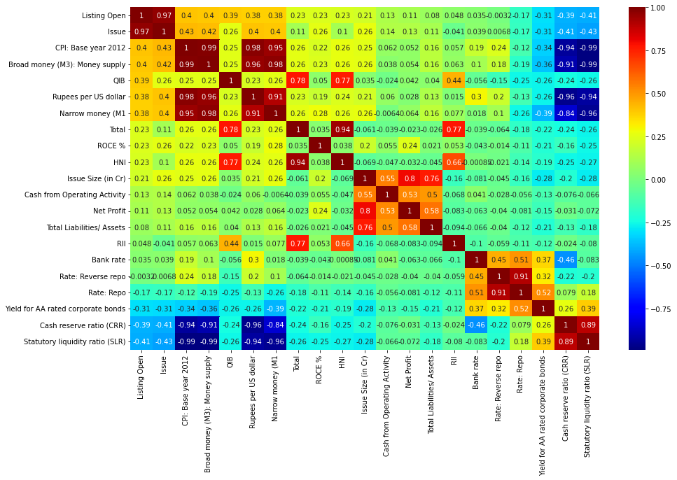

Next, we plotted histograms to get an understanding of the distribution of our variables. This showed that listing price (dependent variable) is normally distributed. Lastly, we plotted box plots to get a better insight into the distribution of the variables and check for outliers. Most independent variables had outliers; Listing price (dependent variable) also had outliers. For further analysis, outliers were removed from the dataset.

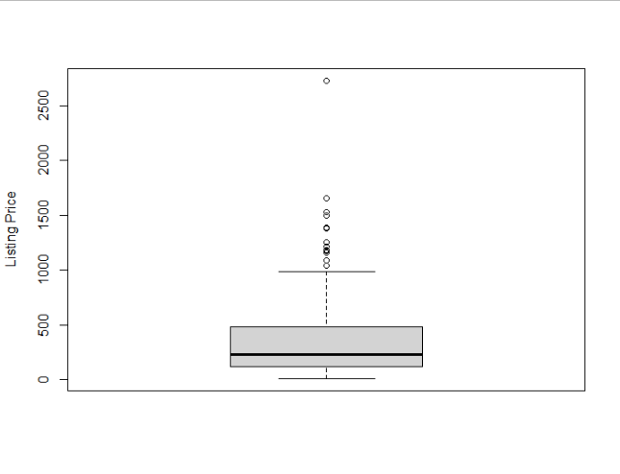

It is clear from the above Boxplot that Listing price is positively skewed and has multiple outliers. To ensure that created regression model fits into all underlying assumptions of MLR we have removed 12 IPOs Where an outlier would be a point below [Q1- (1.5) IQR] or above [Q3+(1.5) IQR].

# Statistical Methodology

## **Principal Component Analysis (PCA)**

Principal component analysis (PCA) is data reduction method used to re-express multivariate data with fewer dimensions. The goal of these methods is to re-orient the data so that a multitude of original variables can be summarized with relatively few “factors” or “components” that capture the maximum possible information (variation) from the original variables. It is undertaken in cases when there is a sufficient correlation among the original variables to warrant the factor/component representation.

1. **Factor Retention**

Since principal component analysis is a data reduction method, there is a need to retain an appropriate number of factors based on the trade-off between simplicity (retaining as few as possible factors) and completeness (explaining most of the variation in the data). The Kaiser’s rule recommends retaining only factors with eigenvalues *λ* exceeding 0.7. Intuitively, this rule means that any retained factor *z* should account for at least as much variation as any of the original variables x. In practice, the scree plot of the eigenvalues is examined to determine whether there is a “break” in the plot with the remaining factors explaining considerably less variation.

1. **Factor Rotation**

The factor loadings matrix is usually “rotated” or re-oriented in order to make most factor loadings on any specific factor small while only a few factor loadings are large in absolute value. This simple structure allows factors to be easily interpreted as the clusters of variables that are highly correlated with a particular factor. The goal is to find clusters of variables that to a large extent define only one factor.

* **Orthogonal rotation** – preserves the perpendicularity of the axes (rotated components/factors remain uncorrelated).
* **Varimax rotation** –preserves simple structure by focusing on the columns of the factor loading matrix. The Kaiser’s varimax rotation is an orthogonal rotation (preserving the independence of the factors) aiming to maximize the squared loadings variance across variables summed over all factors.
* **Quartimax rotation** – preserves simple structure by focusing on the rows of the factor loading matrix.
* **Oblique rotation** – allows for correlation between the rotated factors. The purpose is to align the factor axes as closely as possible to the groups of the original variables. The goal is to facilitate the interpretation of the results.

## **Multiple Linear Regression (MLR)**

Multiple linear regression (MLR), also known simply as multiple regression, is a statistical technique that uses several explanatory variables to predict the outcome of a response variable. The goal of multiple linear regression is to model the linear relationship between the explanatory (independent) variables and the response (dependent) variables. In essence, multiple regression is the extension of ordinary least-squares (OLS) regression because it involves more than one explanatory variable. The coefficient of determination (R-squared) is a statistical metric that is used to measure how much of the variation in outcome can be explained by the variation in the independent variables. R2 always increases as more predictors are added to the MLR model, even though the predictors may not be related to the outcome variable. R2 by itself cannot therefore be used to identify which predictors should be included in a model and which should be excluded. R2 can only be between 0 and 1, where 0 indicates that the outcome cannot be predicted by any of the independent variables and 1 indicates that the outcome can be predicted without error from the independent variables. When interpreting the results of multiple regression, beta coefficients are valid while holding all other variables constant ("all else equal"). The output from a multiple regression can be displayed horizontally as an equation, or vertically in table form.

* **Formula and Calculation of Multiple Linear Regression**

$y_{i}=β_{0}+β_{1}x_{i1}+β_{2}x_{i2}…...β_{p}x_{ip}$ (i = n observations)

Where,

$y_{i}=$ Dependent variable

$x_{i}$ = Explanatory Variable

$β_{0}=$ y-intercept

$β_{p}=$ Slope coefficient for each explanatory variable

* **Assumptions**

1. There is a linear relationship between the dependent variables and the independent variables
2. The independent variables are not too highly correlated with each other
3. $y_{i}$ observations are selected independently and randomly from the population
4. Residuals should be normally distributed with a mean of 0 and variance σ
5. The variance of the residuals is constant

# Statistical Analysis

The statistical techniques used here were Principal Component Analysis followed by Multiple Regression Analysis technique. Principal component analysis was conducted on the 11 macroeconomic variables to determine which among them will be suitable for multiple regression modelling. Before starting with the PCA a correlation matrix was made among the all the variables which showed that all the variables had at least one correlation coefficient greater than 0.4. According to Kaiser-Meyer-Olkin (KMO) we consider those components whose Eigen values are more than 0.7.

PCA revealed that there were three components, M1, M3 and Exchange Rate that had eigenvalues greater than 0.7 and which explained 59.68%,25.75% and 7.23% of the total variance, respectively.

Visual inspection through Scree Plot also indicated that there were three components that needed to be retained as the major bending of the curve happens after the 3rd component.

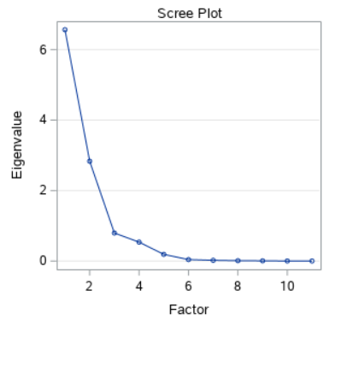

Altogether, the three components explained 92.66% of the total variation in the system. Hence, a varimax orthogonal rotation matrix was made to aid interpretability. The table given below show the detailed information of the PCA results.

|  |  |  |  |  |  |  |  |  |
| --- | --- | --- | --- | --- | --- | --- | --- | --- |
|  | **Rotated Factor Pattern** | | | | **Initial Eigen Values** | | | |
| **Components** | **Factor1** | **Factor2** | **Factor3** | **Communality Estimates** | **Eigenvalue** | **Difference** | **Proportion** | **Cumulative** |
| ***M1*** | ***0.95155*** | ***-0.02391*** | ***0.12596*** | ***0.92187942*** | ***6.56447692*** | ***3.73169428*** | ***0.5968*** | ***0.5968*** |
| ***M3*** | ***0.98558*** | ***0.05977*** | ***0.08688*** | ***0.98249308*** | ***2.83278264*** | ***2.03782051*** | ***0.2575*** | ***0.8543*** |
| ***ER*** | ***0.96542*** | ***0.16777*** | ***-0.10231*** | ***0.97065588*** | ***0.79496213*** | ***0.25789802*** | ***0.0723*** | ***0.9266*** |
| **CRR** | -0.93999 | -0.2248 | 0.2227 | 0.98371333 | 0.5370641 | 0.34835609 | 0.0488 | 0.9754 |
| **BR** | 0.15036 | 0.73489 | -0.58114 | 0.90040388 | 0.18870802 | 0.14716784 | 0.0172 | 0.9925 |
| **CPI** | 0.98718 | 0.12979 | 0.04734 | 0.99361429 | 0.04154017 | 0.02081467 | 0.0038 | 0.9963 |
| **RR** | -0.23237 | 0.9241 | 0.26367 | 0.97747566 | 0.0207255 | 0.01024844 | 0.0019 | 0.9982 |
| **RRR** | 0.13649 | 0.88853 | 0.41013 | 0.97632271 | 0.01047707 | 0.00415695 | 0.001 | 0.9992 |
| **SLR** | -0.97997 | -0.05147 | -0.13078 | 0.98009059 | 0.00632011 | 0.00464008 | 0.0006 | 0.9997 |
| **YSCM1** | -0.81098 | 0.42615 | 0.1398 | 0.85883311 | 0.00168003 | 0.00041673 | 0.0002 | 0.9999 |
| **YSCM2** | -0.42924 | 0.60444 | -0.31168 | 0.64673973 | 0.00126331 |  | 0.0001 | 1 |

The variables considered after doing PCA are M1, M3 and Exchange Rate which are highlighted in the table above.

(**Note:** M1: Narrow Money, M3: Broad Money, ER: Exchange Rate, CRR: Cash Reserve Ratio, BR: Bank Rate, CPI: Consumer Price Index, RR: Repo Rate, RRR: Reserve Repo Rate, SLR: Statutory Liquidity Ratio, YSCM1: Yield in secondary market: AA rated corporate bonds, YSCM2: Yield in secondary market: AAA rated corporate bonds.)

**Multiple Linear Regression**

The dependent variable is transformed using square root transformation for reducing heteroscedasticity of the residuals in linear regression.

**Summary of Multiple linear regression model created -**

The Regression Model is -

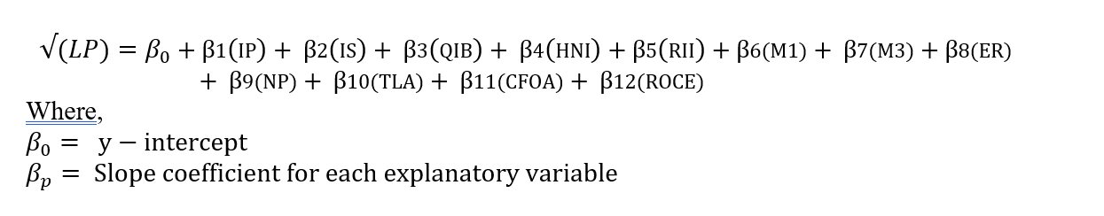

|  |  |  |  |
| --- | --- | --- | --- |
| Variable | Estimate | *Std. Error* | *P value* |
| (Intercept) | **7.331** | **0.2646** | **< 2e-16** |
| IP | **0.02702** | **0.0007271** | **< 2e-16** |
| IS | -0.000178 | 0.0001608 | 0.2697 |
| QIB | **0.02681** | **0.006166** | **0.0000221** |
| HNI | **0.003337** | **0.001928** | **0.0085** |
| RII | -0.004629 | 0.01802 | 0.7975 |
| M1 | 0.3258 | 0.1585 | 0.0611 |
| M3 | -0.1921 | 0.1261 | 0.1292 |
| ER | -0.02951 | 0.1290 | 0.8192 |
| NP | 0.0001954 | 0.0003019 | 0.5181 |
| TLA | -0.00000185 | 0.00001199 | 0.8773 |
| CFOA | 0.00009221 | 0.00009644 | 0.3401 |
| ROCE | **2.834** | **0.7892** | **0.000417** |

* Residual standard error: 1.783 on 196 degrees of freedom
* Multiple R-squared: 0.9351
* Adjusted R-squared: 0.9311
* F-statistic: 235.2 on 12 and 196 DF,
* p-value: < 2.2e-16

**Assumptions for Multiple Linear Regression Model Created:**

1. **Multicollinearity**

|  |  |  |  |  |
| --- | --- | --- | --- | --- |
| Variable | VIF |  | Variable | VIF |
| IP | 1.728598 |  | M2 | 1.095897 |
| IS | 4.875420 |  | ER | 1.101311 |
| QIB | 2.499854 |  | NP | 3.366811 |
| HNI | 3.624853 |  | TLA | 2.645929 |
| RII | 2.070095 |  | CFOA | 1.655784 |
| M1 | 1.630407 |  | ROCE | 1.216479 |

Since all the Variance inflation factor (VIF) are less than 5, we can conclude that **multicollinearity does not exist.**

1. **Homoscedasticity**

Test for homoscedasticity is tested using Breusch Pagan test.

H0: Error variances are equal Vs H1: Error variances are not equal (α = 0.05)

(Decision Criterion: Reject H0 if p value < 0.05)

|  |
| --- |
| studentized Breusch-Pagan test data: model2 BP = 11.259, df = 12, *p-value = 0.5069* |

As p-value = 0.5069 > 0.05, signifies that do not reject H0 at 5% level of significance.

i.e., Error variance is constant.

Hence, **the variances are equal which predicts that the model is homoscedastic**

1. **Normality of residuals**

Since the points in the Q-Q plot appears to be on the 45-degree straight line with little deviation in star and end of the Q-Q plot, **it suggests that the residuals are normally distributed**.

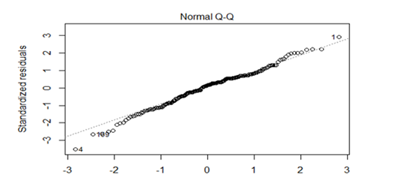

Now confirming normality using Shapiro – wilk test -

H0: Residuals are normally distributed. vs H1: Residuals are not normally distributed

(Decision Criterion: Reject H0 for p-value < 0.05)

|  |
| --- |
| Shapiro-Wilk normality test data: model1$residualsW = 0.98803, *p-value = 0.07686* |

p-value = 0.07686 > 0.05 So, we do not reject H0 at 5% level of significance. Hence**, residuals are normally distributed.**

1. **Autocorrelation**

Durbin-Watson test for autocorrelation/independency among residuals.

H0: No Autocorrelation among residuals Vs H1: Presence of Autocorrelation among residuals

(Decision Criterion: Reject H0 for p-value < 0.05)

|  |
| --- |
| Lag Autocorrelation D-W Statistic  *p-value*  1 0.01851086 1.923886  *0.488* |

From the above result it can be interpreted that p-value = 0.488 > 0.05, signifies that

So, we do not reject H0 at 5% level of significance.

Hence, **there is no Autocorrelation among residual**

Hence all the assumptions of multiple linear regression are satisfied

* **Global Testing**

H0: β1= β2= β3= β4= β5= β6= β7= β8= β9= β10= β11= β12= 0

H1: Not H0  (α = 0.05)

(Decision criterion: Reject H0 if p- value < 0.05)

P-value < 2.2e-16 < 0.05.

So, we reject H0 at 5% level of significance for the given sample.

**Thus, a linear statistical relationship exists between Listing Day price (LP) and at least one of the independent variables.**

* **Individual Testing**

Hypothesis to test -

H0n: βn = 0 Vs H1n: βn ≠ 0

(Decision Criterion: Reject H0 for p-value < 0.05)

From the summary table it can be seen that for IP (issue price), QIB (subscription rate of qualified institutional buyers), HNI (subscription rate of HNI) ROCE (Return on capital employed) has p – value less than 0.05

Hence, we reject H0 and conclude that -

* Variation in Issue price contributes to variation in Listing price (LP).
* Variation in subscription rate of qualified institutional buyers (QIB) contributes to variation in Listing price (LP).
* Variation in subscription rate of High Network Individuals (HNI) contributes to variation in Listing price (LP).
* Variation in Return on capital employed (ROCE) contributes to variation in Listing price (LP).

For other factors such as Issue Size, Subscription rate RII, M1, M3, ER, net profit, total liabilities or assets, Cash flow from operating activity, we do not reject H0.

This implies,

β2= β5= β6= β7= β8= β9= β10= β11= 0

i.e., These variables do not contribute significantly for variation in listing price.

* **Measure of Goodness of Fit**

Multiple R-squared: 0.9311

That means that variation in independent variables explain 93.11% of variation in Listing Price

i.e., variation in issue price (IS), subscription rate of Qualified Institutional Buyers (QIB), and High Net-worth Individual (HNI), Return on capital employed (ROCE) explain 93.11% of the variation in Listing Price.

Hence based on our study, for prediction of listing price we recommend following regression equation

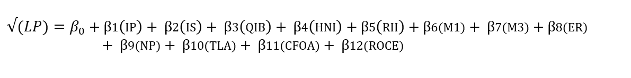

But from individual testing we get,

β2= β5= β6= β7= β8= β9= β10= β11= 0

Now, the equation reduces to -

|  |
| --- |
| √(LP) = 7.331 + 0.02702 (IP) + 0.02681 (QIB) + 0.003337 (HNI) + 2.834 (ROCE)  **LP = (7.331 + 0.02702 (IP) + 0.02681 (QIB) + 0.003337 (HNI) + 2.834 (ROCE))2** |

# Conclusion

In this paper, the factors affecting listing day prices of an IPO in India are studied. In order to do so, the three type of IPO-specific factors Subscription and Listing Factors, Macroeconomic Factors and Company Financials are considered.

* After performing multiple linear regression, it is clear that Issue Price, Subscription Rate of QIB and HNI, Return on Capital Employed have a positive relationship and significantly affect the Listing Price.
* Macroeconomic variables do not have significant effect on the ultra-short-term performance (Listing Day performance) on an IPO.
* Other Company Financials such as Net Profits, Total Assets, Cash from Operating Activities, do not have a significant effect on the short-term performance on an IPO.

# Limitations

* The scope of the study is limited to only the IPOs issued from April 2009 to March 2020. Only 232 IPOs which went public on both NSE and BSE during this time period are taken into consideration.
* All SME IPOs and Secondary Equity Offerings (SEO) are excluded from our study due to insufficient data and other factors.
* Outliers were removed from the dependent variable (Listing Price) to make the model fit the study. The outliers were the result of a few IPOs which were having very high or very low price per share, which were affecting the normality of residuals in the model.

# Future Scope

* For future research, we suggest the extension of this analysis for additional explanatory variables including leverage at IPO date, age of IPO firm, promoter groups retention, some more company specific financial ratios and grey market premium (GMP).
* The scope of the research study could even be improved by extending the time period of study prior to 2010.
* A similar approach can also be used to model the long-term performance of these IPOs.

# References

* Phadke, K. M., & Kamat, M. S. (2018). Impacts of Macroeconomic and IPO Factors on underpricing of Initial Public Offerings on the National Stock Exchange (NSE) in India. *International Journal of Management Studies*, *5*(1(4)), 46. <https://doi.org/10.18843/ijms/v5i1(4)/07>
* Savya, D. S. (2020). *An Evaluation of the Performance of Initial Public Offers*. PES IAMS.
* Sahoo, S., & Rajib, P. (2010). After Market Pricing Performance of Initial Public Offerings (IPOs): Indian IPO Market 2002–2006. *Vikalpa: The Journal for Decision Makers*, *35*(4), 27–44. <https://doi.org/10.1177/0256090920100403>
* Marisetty, V. B., & Subrahmanyam, M. G. (2010). Group affiliation and the performance of IPOs in the Indian stock market. *Journal of Financial Markets*, *13*(1), 196–223. <https://doi.org/10.1016/j.finmar.2009.09.001>
* Gujrati, D. (2021). *Basic Econometrics, 6th Edition*. MC GRAW HILL INDIA.

# Appendix

**R CODE FOR EDA**

|  |
| --- |
| boxplot(data$Listing.Price,  ylab="Listing Price")  install.packages("ggplot2")  library(ggplot2)    ggplot(data)+  aes(x=Listing.Price)+  geom_histogram() |

**SAS CODE FOR PCA**

|  |
| --- |
| PROC IMPORT DATAFILE="/home/u59122587/DEmo/DAT/IPOC.csv"  DBMS=CSV  OUT=work.IPOC;  RUN;    ODS RTF FILE="IPO.RTF";  %LET XIST= M1 M3 ER CRR BR CPI RR RRR SLR YSCM1 YSCM2;    proc factor data= work.ipoc  method=principal  n=3  plots=scree  rotate=varimax  out=data;    var &xist;    run;  ODS RTF CLOSE;  proc print data=data;  run;  proc export data=data  outfile="/home/u59122587/DEmo/DAT/IPOM.xlsx"  dbms=xlsx  replace;  run; |

**R CODE FOR MLR**

|  |
| --- |
| data <- read_excel("mlr data (1).xlsx", sheet = "Sheet3")  View(data)    #outliers removal  outliers<-boxplot(data$LP)$out  x<-data  x<- x[-which(x$LP %in% outliers),]  View(x)  #SQR ROOT MODEL  model1 <- lm( sqrt(LP) ~ IP + IS + QIB + HNI + RII + M1 + M3 + ER + NP + TLA + CFOA + ROCE ,data=x)  summary(model1)    # To check multicollinearity  library(car)  vif(model1)    #To test for autocorrelation/independency among residuals.  durbinWatsonTest(model1)    #To check normality of errors by q-q plot  plot(model1 , 2)    # To test Normality of residuals BY Shapiro-Wilk Test  shapiro.test(model1$residuals) |